CHO MÔ MÔ HÌNH MẠNG BÊN DƯỚI:

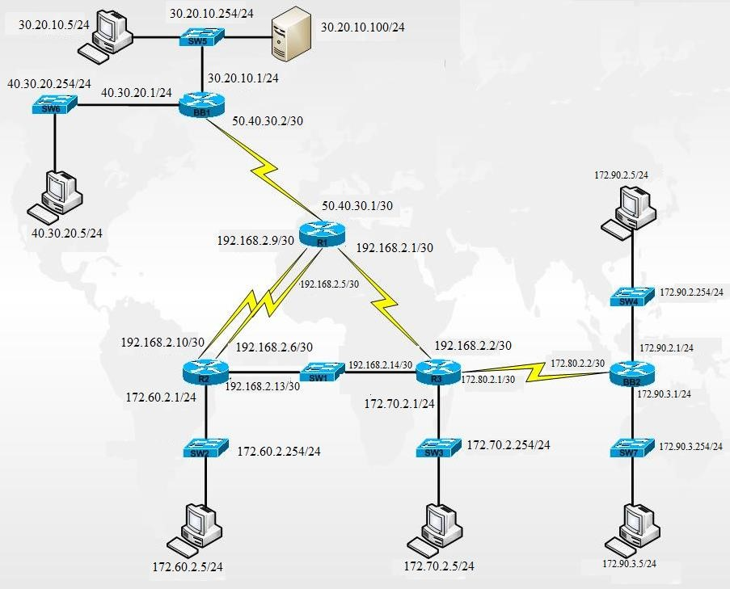



**Bài 1: CẤU HÌNH THÔNG TIN CHO TOÀN MẠNG**

Switch(config)#int vlan1

Switch(config-if)#ip address 30.20.10.254 255.255.255.0

Switch(config-if)#ip default-**gate**way 30.20.10.1

Switch(config)#exit

<https://khoserver.com/huong-dan-cau-hinh-switch-co-ban-danh-cho-nguoi-moi/#tao-vlan>

Chia mạng **192.168.2.0/24** để có được các mạng con nhỏ **/30**, nghĩa là mỗi mạng chỉ có 4 địa chỉ IP, trong đó 2 địa chỉ dùng để gán cho các thiết bị (như các router), 1 địa chỉ là địa chỉ mạng và 1 địa chỉ là địa chỉ broadcast.

* **192.168.2.0/24** thuộc lớp B:
  + Địa chỉ IP từ **192.168.2.0** đến **192.168.2.255**.
  + Tổng số địa chỉ IP: 2(32−24) =28=256 địa chỉ.
  + Trong đó, 1 địa chỉ là địa chỉ mạng (**192.168.2.0**) và 1 địa chỉ là địa chỉ broadcast (**192.168.2.255**).

**Chia mạng 192.168.2.0/24 thành các mạng /30**

* Một mạng con **/30** có mặt nạ mạng con là **255.255.255.252**, tương ứng với 4 địa chỉ IP trong mỗi mạng con
* Còn lại 2 bit host 🡪 22 = 4 địa chỉ IP/subnet; số bit mượn = 6 🡪 số mạng con = 26 = 64; khoảng cách giữa 2 mạng ở octet 4 = 256-252 = 4.
* Các dải địa chỉ sẽ được tính toán như sau:

| **Mạng con** | **Địa chỉ mạng** | **Địa chỉ IP** | **Địa chỉ broadcast** |
| --- | --- | --- | --- |
| **Mạng 1** | 192.168.2.0/30 | 192.168.2.1 - 192.168.2.2 (R1-R3) | 192.168.2.3 |
| **Mạng 2** | 192.168.2.4/30 | 192.168.2.5 - 192.168.2.6 (R1-R2) | 192.168.2.7 |
| **Mạng 3** | 192.168.2.8/30 | 192.168.2.9 - 192.168.2.10 (R1- R2) | 192.168.2.11 |
| **Mạng 4** | 192.168.2.12/30 | 192.168.2.13 - 192.168.2.14 (R2-R3) | 192.168.2.15 |
| **Mạng 5** | 192.168.2.16/30 | 192.168.2.17 - 192.168.2.18 | 192.168.2.19 |
| **Mạng 6** | 192.168.2.20/30 | 192.168.2.21 - 192.168.2.22 | 192.168.2.23 |
| **…** | … | … | … |
| **Mạng 64** | 192.168.2.252/30 | 192.168.2.253 - 192.168.2.254 | 192.168.2.255 |

**BB1 quản lý mạng 30.20.10.0/24; 40.30.20.0/24; 50.40.30.0/30 (OK)**

🡪 Không quản lý mạng: 192.168.2.0/30; 192.168.2.4/30; 192.168.2.8/30; 192.168.2.12/30; 172.60.2.0/24; 172.70.2.0/24; 172.80.2.0/**30**; 172.90.2.0/24; 172.90.3.0/24

ip route 192.168.2.0 255.255.255.252 50.40.30.1

ip route 192.168.2.4 255.255.255.252 50.40.30.1

ip route 192.168.2.8 255.255.255.252 50.40.30.1

ip route 192.168.2.12 255.255.255.252 50.40.30.1

ip route 172.60.2.0 255.255.255.0 50.40.30.1

ip route 172.70.2.0 255.255.255.0 50.40.30.1

ip route 172.80.2.0 255.255.255.252 50.40.30.1

ip route 172.90.2.0 255.255.255.0 50.40.30.1

ip route 172.90.3.0 255.255.255.0 50.40.30.1

**R1 quản lý mạng 50.40.30.0/30; 192.168.2.0/30; 192.168.2.4/30; 192.168.2.8/30**

Dùng lệnh Router# **show ip route**

50.0.0.0/8 is variably subnetted, 2 subnets, 2 masks

C 50.40.30.0/30 is directly connected, Serial0/0/0

L 50.40.30.1/32 is directly connected, Serial0/0/0

192.168.2.0/24 is variably subnetted, 6 subnets, 2 masks

C 192.168.2.0/30 is directly connected, Serial0/0/1

L 192.168.2.1/32 is directly connected, Serial0/0/1

C 192.168.2.4/30 is directly connected, Serial0/2/1

L 192.168.2.5/32 is directly connected, Serial0/2/1

C 192.168.2.8/30 is directly connected, Serial0/2/0

L 192.168.2.9/32 is directly connected, Serial0/2/0

Không quản lý mạng: 30.20.10.0/24; 40.30.20.0/24; **192.168.2.12**/30; 172.60.2.0/24; 172.70.2.0/24; 172.80.2.0/**30**; 172.90.2.0/24; 172.90.3.0/24

ip route 192.168.2.12 255.255.255.252 192.168.2.6

ip route 172.60.2.0 255.255.255.0 192.168.2.6

ip route 172.70.2.0 255.255.255.0 192.168.2.2

ip route 172.80.2.0 255.255.255.252 192.168.2.2

ip route 172.90.2.0 255.255.255.0 192.168.2.2

ip route 172.90.3.0 255.255.255.0 192.168.2.2

ip route 30.20.10.0 255.255.255.0 50.40.30.2

ip route 40.30.20.0 255.255.255.0 50.40.30.2

**R2 quản lý mạng 192.168.2.4/30; 192.168.2.8/30; 192.168.2.12/30; 172.60.2.0/24**

172.60.0.0/16 is variably subnetted, 2 subnets, 2 masks

C 172.60.2.0/24 is directly connected, FastEthernet0/1

L 172.60.2.1/32 is directly connected, FastEthernet0/1

192.168.2.0/24 is variably subnetted, 6 subnets, 2 masks

C 192.168.2.4/30 is directly connected, Serial0/0/1

L 192.168.2.6/32 is directly connected, Serial0/0/1

C 192.168.2.8/30 is directly connected, Serial0/0/0

L 192.168.2.10/32 is directly connected, Serial0/0/0

C 192.168.2.12/30 is directly connected, FastEthernet0/0

L 192.168.2.13/32 is directly connected, FastEthernet0/0

Không quản lý mạng: 30.20.10.0/24; 40.30.20.0/24; 50.40.30.0/30;192.168.2.0/30; 172.70.2.0/24; 172.80.2.0/**30**; 172.90.2.0/24; 172.90.3.0/24

ip route 30.20.10.0 255.255.255.0 192.168.2.9

ip route 40.30.20.0 255.255.255.0 192.168.2.9

ip route 50.40.30.0 255.255.255.252 192.168.2.9

ip route 192.168.2.0 255.255.255.252 192.168.2.14

ip route 172.70.2.0 255.255.255.0 192.168.2.14

ip route 172.80.2.0 255.255.255.252 192.168.2.14

ip route 172.90.2.0 255.255.255.0 192.168.2.14

ip route 172.90.3.0 255.255.255.0 192.168.2.14

**R3 quản lý mạng 192.168.2.0/30; 192.168.2.12/30; 172.70.2.0/24; 172.80.2.0/30**

172.70.0.0/16 is variably subnetted, 2 subnets, 2 masks

C 172.70.2.0/24 is directly connected, FastEthernet0/1

L 172.70.2.1/32 is directly connected, FastEthernet0/1

172.80.0.0/16 is variably subnetted, 2 subnets, 2 masks

C 172.80.2.0/30 is directly connected, Serial0/2/1

L 172.80.2.1/32 is directly connected, Serial0/2/1

192.168.2.0/24 is variably subnetted, 4 subnets, 2 masks

C 192.168.2.0/30 is directly connected, Serial0/2/0

L 192.168.2.2/32 is directly connected, Serial0/2/0

C 192.168.2.12/30 is directly connected, FastEthernet0/0

L 192.168.2.14/32 is directly connected, FastEthernet0/0

Không quản lý mạng: 30.20.10.0/24; 40.30.20.0/24; 50.40.30.0/30; 192.168.2.4/30; 192.168.2.8/30; 172.60.2.0/24; 172.90.2.0/24; 172.90.3.0/24

ip route 30.20.10.0 255.255.255.0 192.168.2.1

ip route 40.30.20.0 255.255.255.0 192.168.2.1

ip route 50.40.30.0 255.255.255.252 192.168.2.1

ip route 192.168.2.4 255.255.255.252 192.168.2.1

ip route 192.168.2.8 255.255.255.252 192.168.2.1

ip route 172.60.2.0 255.255.255.0 192.168.2.1

R3 biết rằng để đến được mạng **172.60.2.0/24;** 192.168.2.4/30; 192.168.2.8/30 (kết nối với R2), nó phải chuyển gói tin qua **R1**. Do đó, địa chỉ **next-hop** mà bạn cấu hình là địa chỉ của **R1** (**192.168.2.1**). Router R1 sau đó sẽ chịu trách nhiệm chuyển gói tin tiếp đến mạng **172.60.2.0/24** qua kết nối với R2.

Lý do **R3** chuyển gói tin qua **R1** để đến mạng **172.60.2.0/24** thay vì chuyển thẳng qua **R2** là do **R3 và R2 không kết nối trực tiếp với nhau** trong sơ đồ mạng. **R1** đóng vai trò trung gian giữa **R3** và **R2**, giúp chuyển gói tin từ **R3** đến **R2**.

ip route 172.90.2.0 255.255.255.0 172.80.2.2

ip route 172.90.3.0 255.255.255.0 172.80.2.2

**BB2 quản lý mạng 172.80.2.0/30; 172.90.2.0/24; 172.90.3.0/24 (OK)**

Không quản lý mạng: 30.20.10.0/24; 40.30.20.0/24; 50.40.30.0/30; 192.168.2.0/30; 192.168.2.4/30; 192.168.2.8/30; 192.168.2.12/30; 172.60.2.0/24; 172.70.2.0/24

ip route 30.20.10.0 255.255.255.0 172.80.2.1

ip route 40.30.20.0 255.255.255.0 172.80.2.1

ip route 50.40.30.0 255.255.255.252 172.80.2.1

ip route 192.168.2.0 255.255.255.252 172.80.2.1

ip route 192.168.2.4 255.255.255.252 172.80.2.1

ip route 192.168.2.8 255.255.255.252 172.80.2.1

ip route 192.168.2.12 255.255.255.252 172.80.2.1

ip route 172.60.2.0 255.255.255.0 172.80.2.1

ip route 172.70.2.0 255.255.255.0 172.80.2.1





KH: BB1, R2, R3 (trừ mạng 172.90.2.0 & 172.90.3.0), BB2

BB1:

no ip route 192.168.2.0 255.255.255.252 50.40.30.1

no ip route 192.168.2.4 255.255.255.252 50.40.30.1

no ip route 192.168.2.8 255.255.255.252 50.40.30.1

no ip route 192.168.2.12 255.255.255.252 50.40.30.1

BB1(config)# no ip route 172.60.2.0 255.255.255.0 50.40.30.1

BB1(config)# no ip route 172.70.2.0 255.255.255.0 50.40.30.1

BB1(config)# no ip route 172.80.2.0 255.255.255.252 50.40.30.1

BB1(config)# no ip route 172.90.2.0 255.255.255.0 50.40.30.1

BB1(config)# no ip route 172.90.3.0 255.255.255.0 50.40.30.1

R2:

no ip route 30.20.10.0 255.255.255.0 192.168.2.9

no ip route 40.30.20.0 255.255.255.0 192.168.2.9

no ip route 50.40.30.0 255.255.255.252 192.168.2.9

no ip route 192.168.2.0 255.255.255.252 192.168.2.14

no ip route 172.70.2.0 255.255.255.0 192.168.2.14

no ip route 172.80.2.0 255.255.255.252 192.168.2.14

no ip route 172.90.2.0 255.255.255.0 192.168.2.14

no ip route 172.90.3.0 255.255.255.0 192.168.2.14

R3:

no ip route 30.20.10.0 255.255.255.0 192.168.2.1

no ip route 40.30.20.0 255.255.255.0 192.168.2.1

no ip route 50.40.30.0 255.255.255.252 192.168.2.1

no ip route 192.168.2.4 255.255.255.252 192.168.2.1

no ip route 192.168.2.8 255.255.255.252 192.168.2.1

no ip route 172.60.2.0 255.255.255.0 192.168.2.1

BB2:

no ip route 192.168.2.0 255.255.255.252 172.80.2.1

no ip route 192.168.2.4 255.255.255.252 172.80.2.1

no ip route 192.168.2.8 255.255.255.252 172.80.2.1

no ip route 192.168.2.12 255.255.255.252 172.80.2.1

BB2(config)# no ip route 172.70.2.0 255.255.255.0 172.80.2.1

BB2(config)# no ip route 172.60.2.0 255.255.255.0 172.80.2.1

BB2(config)# no ip route 50.40.30.0 255.255.255.252 172.80.2.1

BB2(config)# no ip route 40.30.20.0 255.255.255.0 172.80.2.1

BB2(config)# no ip route 30.20.10.0 255.255.255.0 172.80.2.1

ISP: R1